We had some awesome fun events this past season and we want to share our exciting plans for our upcoming season of Verandah Women’s Social Club (VWSC).

Kick-Off/Welcome Back Cocktail Party
Thursday, October 13, 2022, 5:00 – 7:30 PM

Wear your little black dress and join us for an evening of fun with old and new friends, visit the photo booth, and hear more about our upcoming season. Welcome back!

Celebration of The Women of Verandah Dinner
Thursday, November 3, 2022, 5:00 – 7:30 PM

Verandah is an exceptional place to call home and we will hear from speakers representing so many of the wonderful groups and events for women in Verandah; the Sugar Plum Event, Annual Verandah Garage Sale, the Sew & Sews, the Social Butterflies, the Verandah Women’s Social Club (VWSC) and the Swing Singers. Come have dinner with all these wonderful women and join in the fun!
VWSC Sip, Shop, Socialize Pop Up Vendor Event  Tuesday, December 6, 2022 – 5:00 – 7:30 PM  Cocktail Party with Pop Up Vendor Fair - Sip, Shop,  Socialize  Enjoy Cocktails and hors d’ oeuvres and socializing while doing some Holiday shopping | 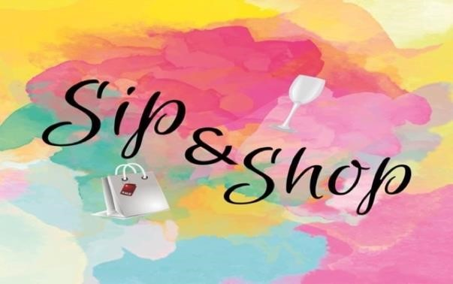
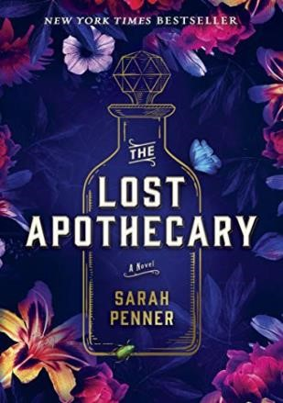 | The Lost Apothecary Book Event Cocktail Party  Thursday, January 19, 2023, 5:00 – 7:30 PM  Book Event Cocktail Party  The Lost Apothecary is a New York Times  bestseller debut book written by Sarah Penner and Fox Broadcasting is developing a television adaptation of novel.  Join us for cocktail and hors d’oeuvres as Sarah talks about her book and shares some magic potions!
VWSC Fashion Show Luncheon
Monday, February 6, 2023, 12:00 – 2:30 PM

Our most popular event is back!

You will be treated to a fabulous luncheon and show featuring clothing from Dillard’s and Verandah Pro Shop, modeled by your friends and neighbors. This event will not disappoint!

VWSC Evening with Elvis Impersonator Cocktail
Party
Tuesday, April 4, 2023, 5:00 – 7:30 PM

Enjoy cocktails and hors d’oeuvres with your neighbors and friends and The King!

Questions/comments, please contact evafix11@gmail.com

VERANDAH WOMEN’S SOCIAL CLUB (VWSC) Board
Lolly Dentkos
Eva Fix
Stephanie Newman
Debbie Piva

